Shepherdswell Academy
Autumn 2 Term Curriculum Overview for Year 2 (Badgers and Foxes). This term our topic is Town and Country.

English  We are going to be looking at traditional tales. This will involve reading different traditional tales. We are going to compare characters and settings from the stories. The skills that we will focus on will be using expanded noun phrases and different coordinating conjunctions.  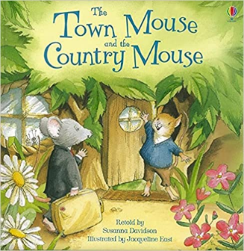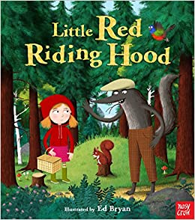 | Maths  We are going to be focusing on measuring; looking at using rulers to measure in centimetres. We will also be comparing and ordering lengths. Following this, we will be looking at the links between multiplication and division. This will involve making equal groups, adding equal groups and using repeated addition. After this we will look at statistics. We will be interpreting and constructing simple pictograms, tally charts and block diagrams. Finally, we will look at position. We will learn to use language to describe position, movement and direction. | Music  We are focussing on celebrations this term including Diwali and Christmas. We will also be singing songs to show our respect on Remembrance Day. Children will use their knowledge of using graphic notations to play percussion instruments including the handbells. We will learn a variety of songs and celebrate with a final performance of their learning. | Science  In Science this half term we will be looking at animals and how they grow. This will involve looking at the life cycle of different animals. We will take this further by looking at how humans develop over from birth to adulthood.
PSHE
We will be celebrating our differences and understanding how everyone should be accepted no matter what their interests and differences are. We will also look at why bullying happens and why it is important to make new friends.
Geography  In geography we will be learning about climate zones. We will be looking at the difference between climate and weather; with a focus on polar, tropical and desert regions.  We will use our links to science to look at the weather conditions in each climate zone and what animals can survive there. | P.E  Ball Skills: In this unit, pupils will develop their fundamental ball skills such as throwing and catching, rolling, hitting a target, dribbling with both hands and feet and kicking a ball. Pupils will have the opportunity to work independently, in pairs and small groups.  Team Building: In this unit pupils develop their communication and problem solving skills. They work individually, in pairs and in small groups, learning to take turns, work collaboratively and lead each other. They are given the opportunity to discuss and plan their ideas to get the most successful outcome. | R.E  This term in RE we will be addressing the following question:  Why does Christmas matter to Christians?  We have a Christian visitor coming into school to share her experiences of Christmas as a practising Christian. We will also ensure all the children have the opportunity to share their own experiences of Christmas and what it means to them. We will explore the Bible story of Christmas and find out why this story is so important to the Christian faith.  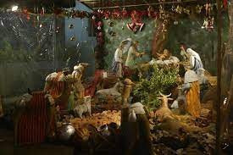 | D.T  This term in DT we will be learning about joining textiles. We will start with exploring different fabrics and then move onto what materials we can use to make a character.  This links to our literacy topic on traditional tales and by the end of this unit we hope to have made our own fabric character puppets.
Computing
This term we will be looking at using algorithms. This will involve using the timer and repeat buttons. We will also look at debugging codes to make programs work correctly.

Subject | Word | Definition
Science | climate | Climate means the usual condition in an area of the Earth's surface for a long time.
 | generation | A group who have been born and live at the same time.
 | life cycle | The changes that an animal or plant goes through during its life.
Computing | debug | Identify and removed errors in code.
 | algorithm | An algorithm is a set of instructions designed to perform a specific task.
English | expanded noun phrases | An expanded noun phrase adds more detail to the noun.
 | coordinating conjunction | Conjunctions are joining words that link together parts of a sentence. Examples of coordinating conjunctions are and, but, or
 | setting | The place or type of surroundings where something is positioned.
Maths | centimetres | A measurement of length, height or depth.
 | metres | A measurement of length or height. There are 100cm to 1 metre.
 | length | Is the measure of the distance between two points to decide how long an object is.
 | height | The distance from the bottom to the top of something standing upright.
 | multiply | The basic idea of multiplication is repeated addition. Example: 5 × 3 = 5 + 5 + 5 = 15. To multiply something is to repeatedly add something a number of times.
 | anti-clockwise | If something is moving anti-clockwise, it is moving in the opposite direction to the direction in which the hands of a clock move.
 | clockwise | In the direction in which the hands of a clock rotate around a clock.
 | rotate | To cause to turn around an axis or centre point.
 | direction | Is defined as the path that something takes, the path that must be taken to reach a specific place.
 | position | The place where someone or something is in relation to other people or things.
PE | Teamwork | The ability to work together with others to solve challenges and complete team-based activities.
 | Communication | How we get information to and from each other. This can be done verbally by talking and listening to each other or making signals and signs with our bodies for other people to pick up on. A thumbs up is a good example of this.
 | Planning | To plan is to map out an idea and actions to solve a challenge or complete an activity. You can plan on your own or as part of a team.
 | Distance | How far something is from a starting point or between two objects.
 | Overarm | A one-handed technique used to throw an object longer distances. The throwing arm comes up and starts above the shoulder.
 | Underarm | A one-handed technique used for throwing objects shorter distances accurately. The throwing arm is swung back and forth under the shoulder.
 | Receive | To claim an object that has been sent towards you. For example, a fielder in Cricket receiving the ball that has been thrown towards them.
 | Send | To throw or kick an object towards a target. For example, a footballer kicking the ball to a teammate.

How you can support at home this term:
- Geography: To look at maps and find the Equator, polar regions (North pole and South pole), tropical rainforests (The Amazon and The Congo) and deserts (The Sahara and The Gobi Desert).

- DT: To look at different textiles that objects at home are made from. What textiles are soft? What are hard? How else can we describe materials?

- Science: To have discussions about how we change as humans as we get older. This could involve looking at family photos together.

- English: Reading different traditional tales together and then discussing how they are same or different to other traditional tales.
Some you may wish to read include: Sleeping Beauty, Cinderella, Hansel and Gretel, Snow White and the Seven Dwarves.
A great book that has lots of different traditional tales is The Illustrated Grimm's Fairy Tales (Usborne Illustrated Story Collections)

- Phonics: Practise sounds at home. Here is a really useful website- https://home.oxfordowl.co.uk/reading/reading-schemes-oxford-levels/read-write-inc-phonics-guide/

- Spelling: Practise reading and writing the common exception words sent home.

- PE: Play target games at home with your children. You can create a target out of anything found around your home and you can use a rolled-up pair of socks as a ball. Encourage your child to throw in different ways using both hands together and alternately.

- Please read with your child at least three times a week.

- Maths: To recall facts about measurement. Including 100cm = 1 metre, 10mm = 1cm
To use language such as quarter turn, half turn and full turn to describe movement.
To recall 2, 5 and 10 times table facts. This can be done through the use of Purple Mash. Recommended games include 2Race and Monster Multiplication. There are also great videos that you can watch to learn times tables. These can be found under 2Simple Table Toons.
NumBots website or app. NumBots is an online game and playing little and often will significantly improve your child’s recall and understanding of number bonds and addition and subtraction facts. These are critical foundations in maths so we are excited by the impact NumBots will have. Children’s log ins will be going out into their reading logs by the end of next week. Aim for playing Story Mode for 5 minutes a few times a week. To get the best out of NumBots, little and often is key.

